**Project One**

**INF240 – Prof. Stoilov**

**Etjen Ymeraj**



*The submitted assignment is all my own work; I did not copy the material from someone else; I did not use any Web design software; No one but me developed the web site.*

*I have successfully completed the assignment.*

*Date Signature*

*15/10/2014*

# TABLE OF CONTENTS

## *INTRODUCTION………………….3*

# *HOME PAGE……………………4-5*

## *ABOUT ME PAGE…………….5-6*

## *GALLERY PAGE………………7-8*

## *CONTACT PAGE…………….……8*

## *SCREENSHOTS………………9-12*

## *SOURCE CODE....................13*

*INTRODUCTION*

***The first project of the website development course requires us to build a personal website. My website consists of four different sections. The first one is the home page where I briefly give some information on me. Most of the information involves the area of website development meaning the on hand experience that I possess. The next section is the about me page. It offers information on my interests hobbies and activities such as what sports I like what clubs I am part in etc. The next section is the Gallery Page. The gallery as the name says is composed of photos, which include some of my travels, events that I have attended, and clubs where I go out and pictures around Blagoevgrad. The last section is Contact Page, which simply gives the information for everyone who wants to reach out to me.***

*Home Page*

***The website starts with the Home Page where I have briefly described my experience on the website development area. The layout is simple; it includes a header a picture of me and the paragraph containing the information. It is important for a webpage to be user-friendly and also to have colors that do not hurt the eye of the user. On top of the webpage we have the header, which includes the 4 sections mentioned in the introduction. This serves as a navigation Panel. Below it I have included a header to specify the section and also beside it there is a button linked to Facebook to follow me there. Beneath the header there is my personal photo and besides it there is the second header and the paragraph. This forms the content of the page and they are divided into two columns, one occupied by the photo the other by the information. Below the paragraph there are two logos, which I put there in order for the page to be better looking. I have included also dividers two divide the components within a section.***

<div id="header">

<ul id="menu">

<li><a href="home.html">Home</a></li>

<li><a href="about.html">About Me</a></li>

<li><a href="gallery.html">Gallery</a></li>

<li><a href="contact.html">Contact</a></li>

</ul>

</div>

*As stated this are the menu buttons that serve to navigate between pages.*

<div id="home">

<h1>Home</h1>

<ul id="top-social">

<li><a href="https://www.facebook.com/etien.ymeraj" class="Facebook"><img src="images1/fb.png" width="26" height="26" alt="Facebook" /></a></li>

</ul>

This places the header and the Facebook icon beneath the navigation buttons.

<div class="top-divider"></div>

*This is the divider placed on top of the content.*

<div class="content">

<img src="images1/EtjenYmeraj3601.JPG" width="410" height="320" alt="Smiley face" />

<h2>My name is Etjen Ymeraj, and I am a Website Developer</h2>

<p>I started working with websites at the age of 12. At the time I had no knowledge of any programming or markup language and the way I was working was using already made templates. There were this sites where all I had to do is drag and drop the components and just edit them. Editing only included text modification. Now I am studying at the American University in Bulgaria where I am taking the Website development class. I am majoring in Computer Science and Information Systems.</p>

<ul id="service-icons">

<li class="services-design">Design</li>

<li class="services-mobile">Mobile</li>

</ul>

</div>

*This is the content including the personal picture the paragraph with information on me. Also the two icons are listed as list items below the paragraph.*

<div class="bottom-divider"></div>

*This is the divider in the bottom.*

*ABOUT ME PAGE*

*The about me Page contains again the navigation menu and information on my hobbies interest and activities. The page again includes the top and bottom divider and the code for it is the same. We have here again the header to specify the name of the section and below it the content. The content of this one consists of three columns. On top of every column there is another header specifying the category of the content. Each column has a specified width and padding. All of them are again placed between the two dividers.*

*<h1>About Me</h1>*

*This is the header of the section.*

div class="col">

<h2>Interests</h2>

<p>I have always been attracted to computers and at some point I started to code. I find it very interesting to be able to build something on your own. Technology is evolving every day and in order to keep up one must always learn new techniques. It is an area of study where there is no such things as too much information. That is why it is important to learn a variety of courses in order to have a solid background. With so much recourse today it is not so important to be able to produce the code rather than being able to read and understand it</p>

</div>

<div class="col col-mid">

<h2>Hobbies</h2>

<p>I like watching tv-series a lot involving different topics in areas such as politics, superheroes, history, engineering, law firms and psychology. Also I like playing sports a lot. My favorites one are football, basketball, swimming, airsoft. For the last one I would like to explain that it a better version of paintball where the guns that you carry have the weight of a real weapon and it involves a enormous playing ground like a mountain for example. In Albania there is an official association of Airsoft and with the nature that you find there the game turns out to be amazing</p>

</div>

<div class="col">

<h2>Activities</h2>

<p>I am part of AUBG Olympics. This is an organization here at the American University in Bulgaria that is in charge of most of the sport activities. I find this very helpful since in this organization it is essential to be able to work in team. Time management and teamwork are the main thing. I also like clubbing. My favorite bars are Piano Bar Limited and Underground. What attracts me about this club is that they organize Karaoke where I can sing with my friends</p>

</div>

The three columns specified with a different class tag in order for them to be distinguishable.

*Gallery Page*

*The gallery section is composed of only photos. It includes only the header and the photo catalogue.*

<h1>Photos</h1>

*This is the header of the section.*

<ul id="catalogue">

<li><a href="images/IMG_0008.JPG" title="Candies"><img src="images/IMG_0008.JPG" alt="Smiley face" height="180" width="200" /></a></li>

<li><a href="images/IMG_0124.JPG" title="Folie Terrace"><img src="images/IMG_0124.JPG" alt="Smiley face" height="180" width="200" /></a></li>

<li><a href="images/IMG_0273.JPG" title="Skopje"><img src="images/IMG_0273.JPG" alt="Smiley face" height="180" width="200" /></a></li>

<li class="last"><a href="images/IMG_0279.JPG" title="Duomo"><img src="images/IMG_0279.JPG" alt="Smiley face" height="180" width="200" /></a></li>

<li><a href="images/IMG_0298.JPG" title="Ferrari Engine"><img src="images/IMG_0298.JPG" alt="Smiley face" height="180" width="200" /></a></li>

<li><a href="images/IMG_0336.JPG" title="San Siro"><img src="images/IMG_0336.JPG" alt="Smiley face" height="180" width="200" /></a></li>

<li><a href="images/IMG_0346.JPG" title="Halloween"><img src="images/IMG_0346.JPG" alt="Smiley face" height="180" width="200" /></a></li>

<li class="last"><a href="images/IMG_0485.JPG" title="Snowman"><img src="images/IMG_0485.JPG" alt="Smiley face" height="180" width="200" /></a></li>

<li><a href="images/IMG_0579.JPG" title="Underground"><img src="images/IMG_0579.JPG" alt="Smiley face" height="180" width="200" /></a></li>

<li><a href="images/IMG_0680.JPG" title="Cake"><img src="images/IMG_0680.JPG" alt="Smiley face" height="180" width="200" /></a></li>

<li><a href="images/IMG_0744.JPG" title="Selfie"><img src="images/IMG_0744.JPG" alt="Smiley face" height="180" width="200" /></a></li>

<li class="last"><a href="images/IMG_0784.JPG" title="Skapto2"><img src="images/IMG_0784.JPG" alt="Smiley face" height="180" width="200" /></a></li>

</ul>

*This is the way the photos are organized. Photos are placed in three rows each containing four photos. The distance between the photos is the same. The user can click if he wants to view the full size of the image. This is achieved by using the anchor tag as an html element.*

*Contact Page*

*The contact page just contains my contact information. This information is useful to people who want to reach me. As usual the page is composed by the header and the content.*

<div id="contact">

<h1>Contact</h1>

<div class="top-divider"></div>

<div class="content">

<pre>

<span style="color: #B0E0E6"> Name:</span> Etjen Ymeraj

<span style="color: #B0E0E6"> Email:</span> eny120@aubg.edu

<span style="color: #B0E0E6"> Tel:</span> +00359 87 8898502

<span style="color: #B0E0E6">Address:</span> 54 Alexander Stamboliyski

Blagoevgrad, 2700

Bulgaria

</pre>

</div>

<div class="bottom-divider"></div>

</div>

*In the beginning of the code you can see the header. After that the contact is organized in a predefined way. We also use the span element to color just some words of the whole content.*

*Screenshots*

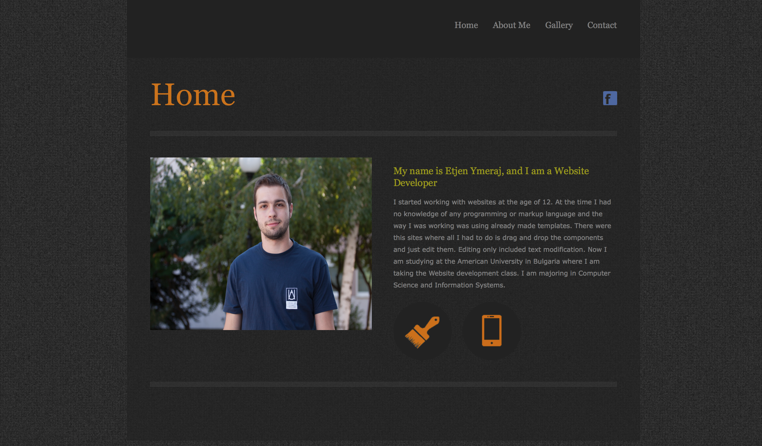

*Home Page*

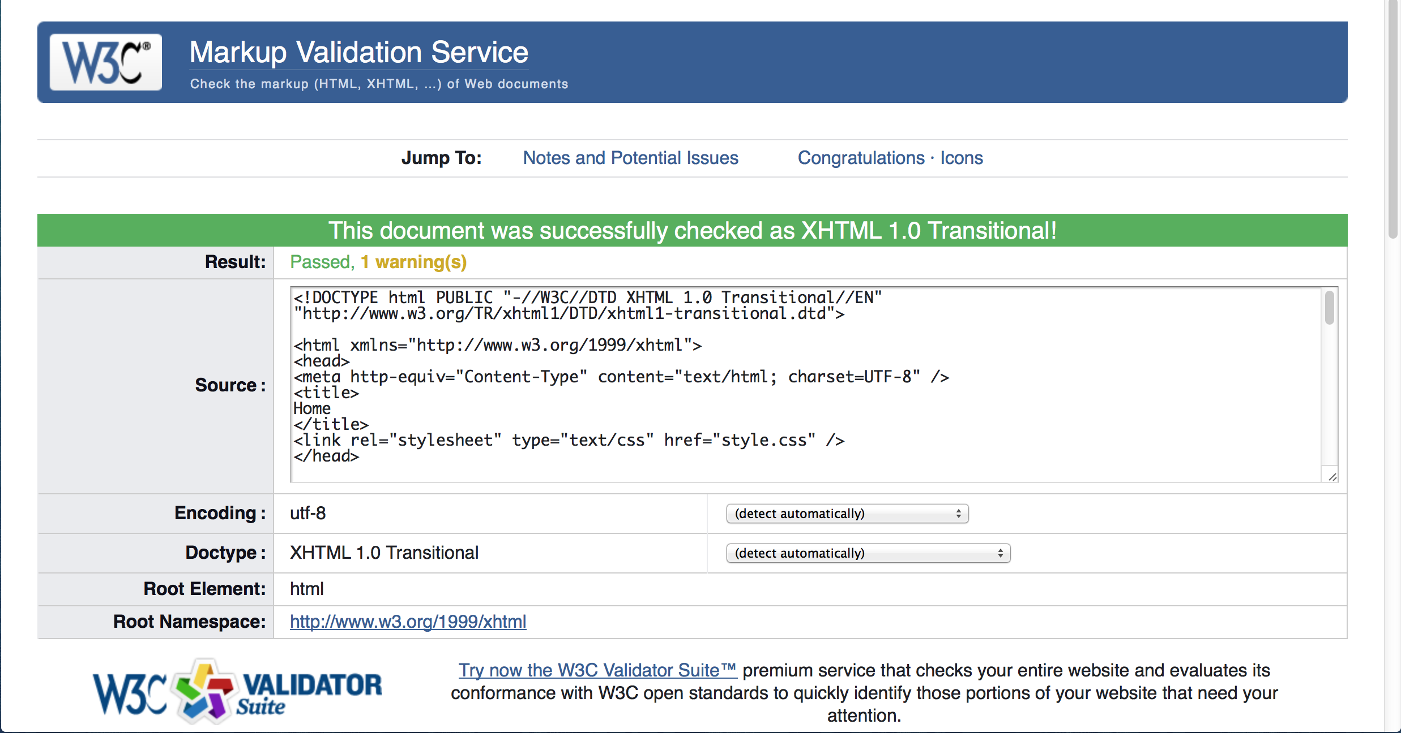

*Validation of Home Page*

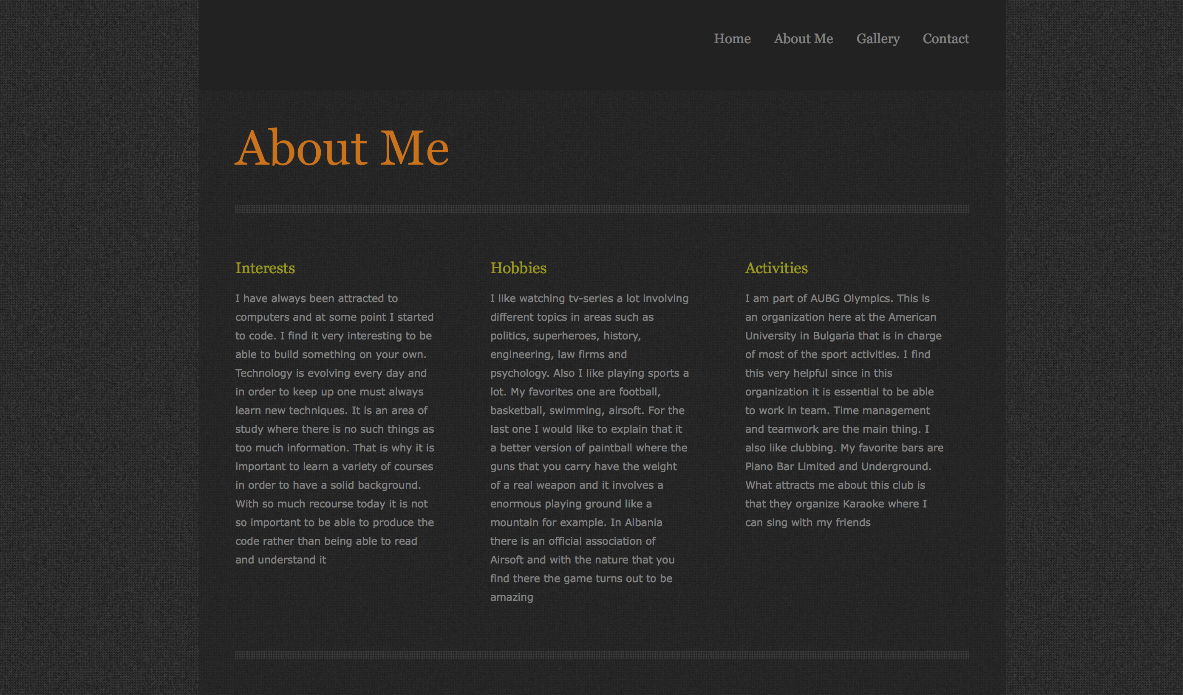

*About Page*

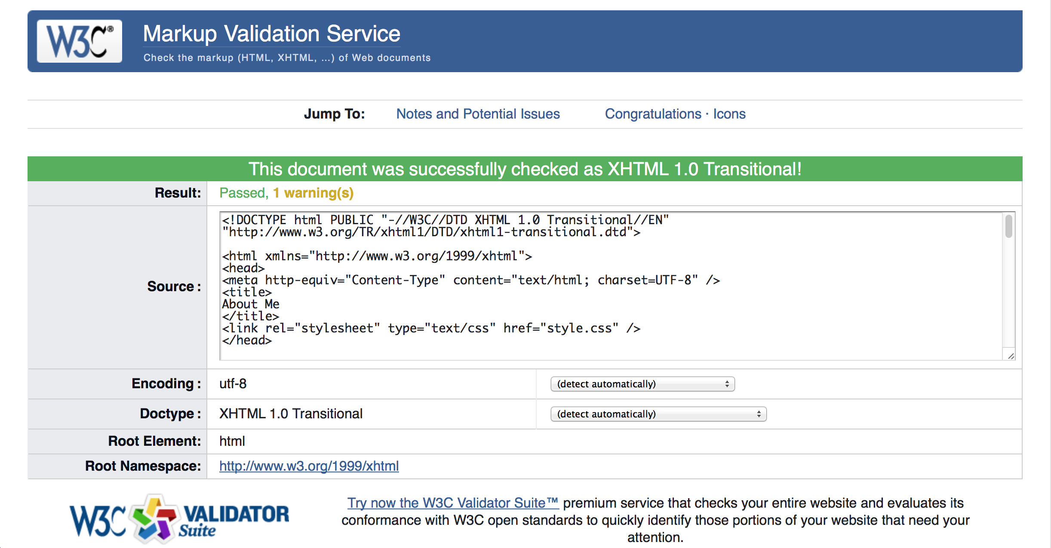

*Validation of About Page*

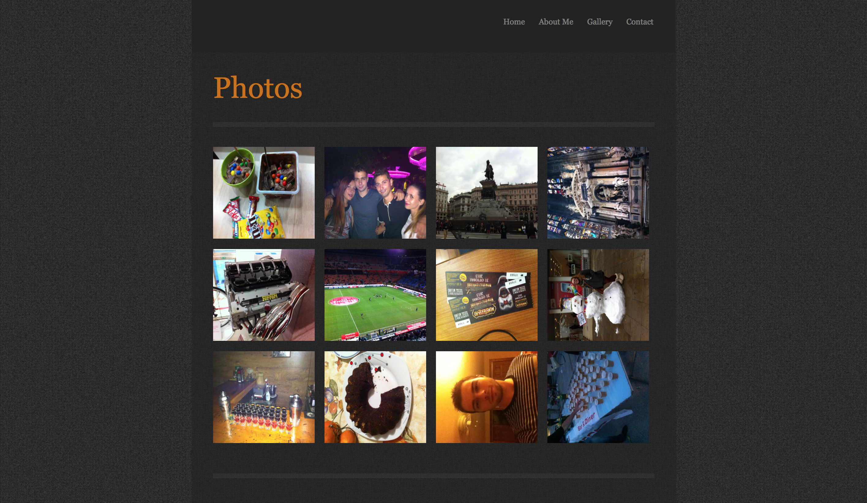

*Gallery Page*

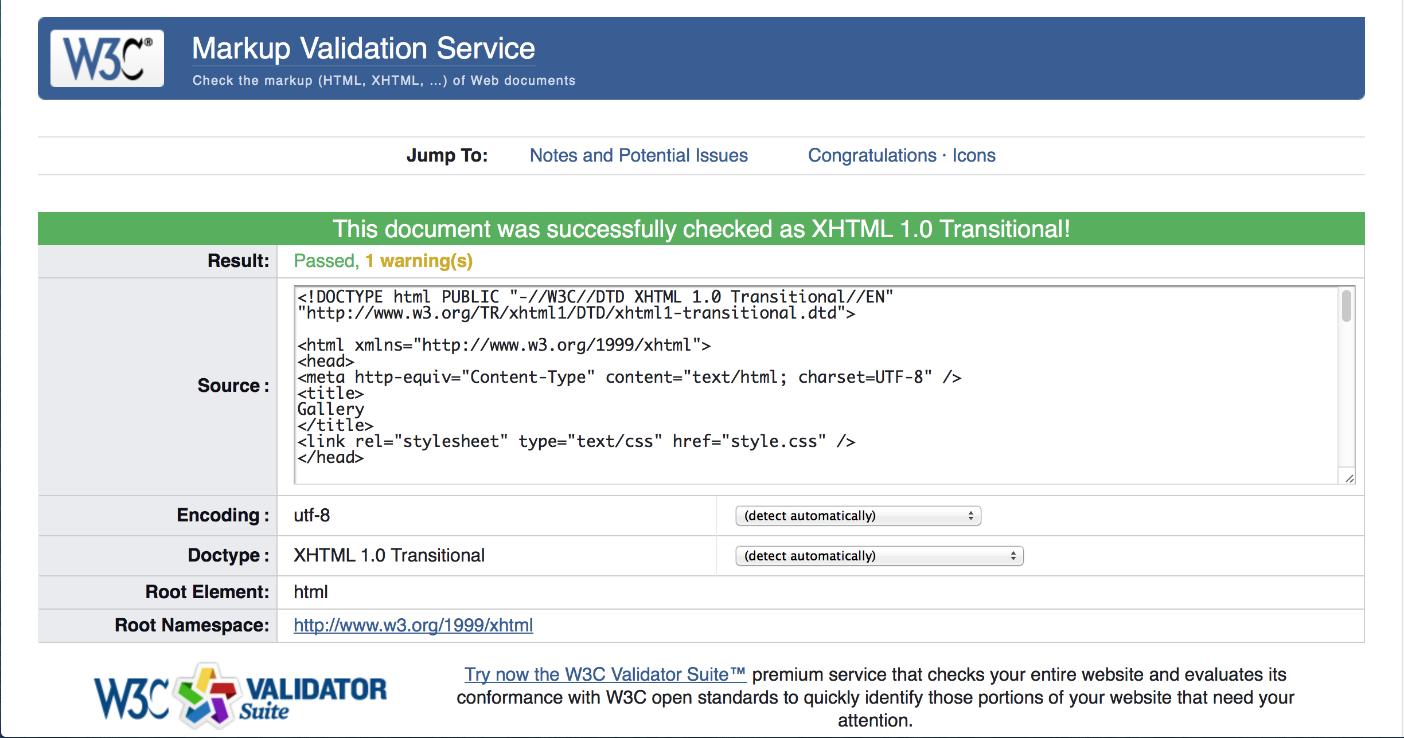

*Validation of Gallery Page*

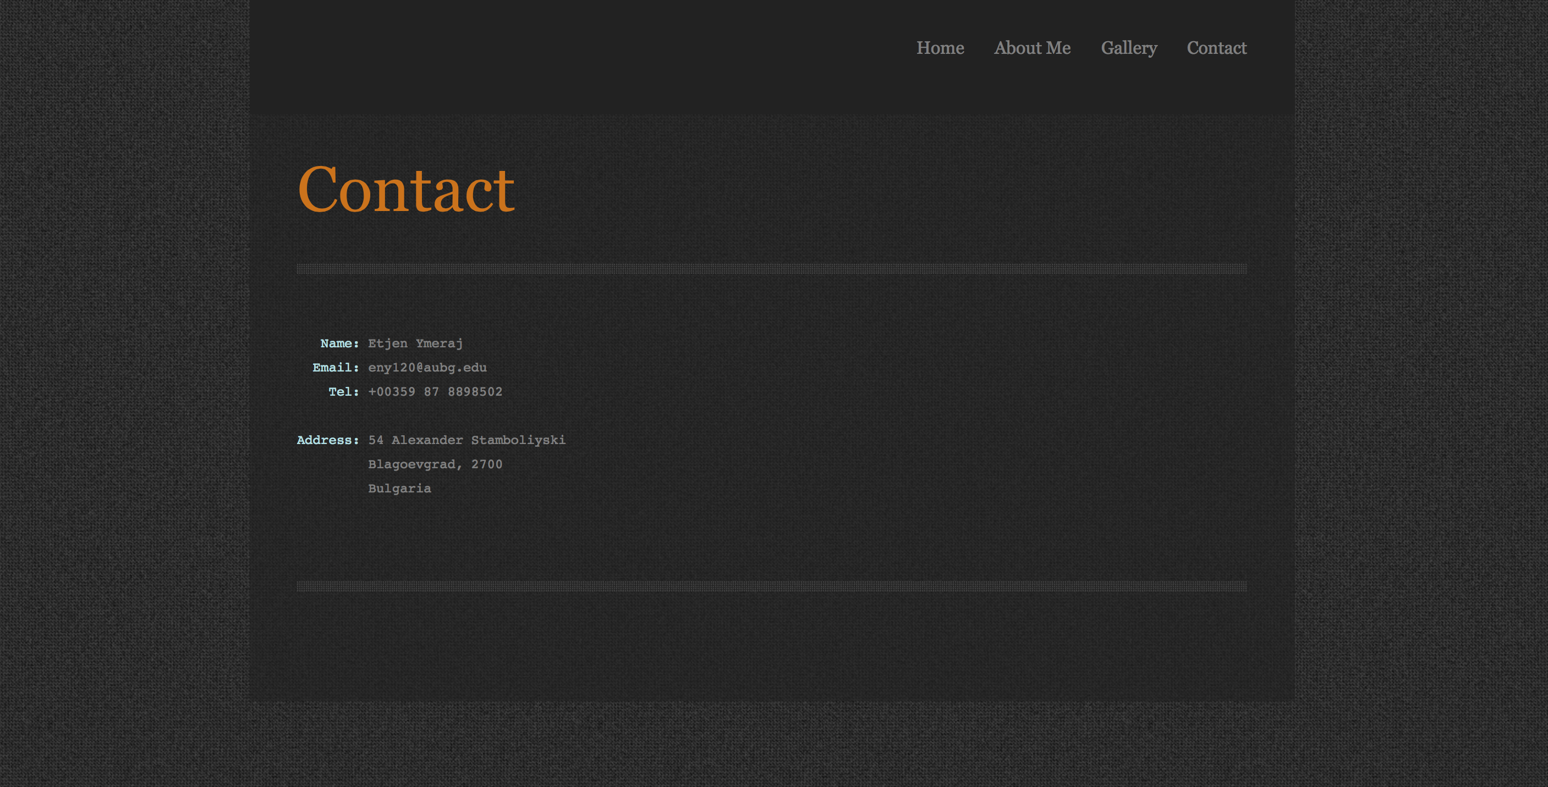

*Contact Page*

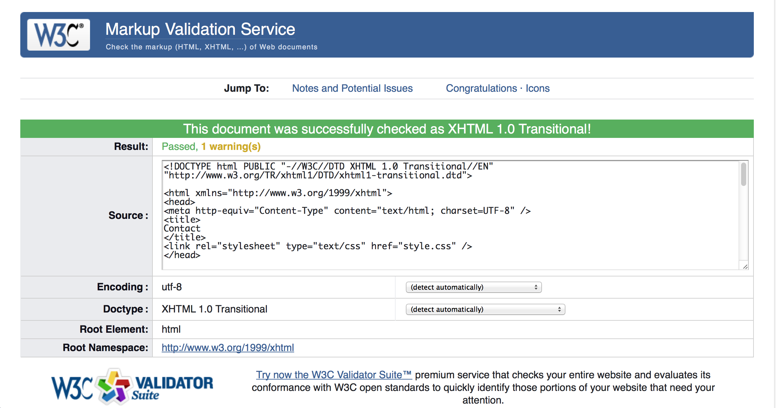

*Validation of Contact Page*

*Source Code*